
The Pondering Pub Roadmap

Worksheet
A Guided Tool for Founders and Leaders. Updated May 2025
Part 1: Gang of One
Figure out why each leader wants to start a Pub. What is the specific reason you are doing this, as opposed to joining something already existing? One can meet friends at a bar or Meetup.com; or talk about books at a library or book club. However, if our mission of creating beauty through community appeals to you, why does it appeal to you personally? This difference is what makes it worth doing. This is going to be your personal rally point, your banner. Each person has their own, and you may need to change your pitch depending on what’s important to you or the other person. Check out our testimonials if you need inspiration as to why people join the Pondering.
- Determine your #1 and #2 reasons for why you’re starting a Pondering Pub. (As opposed to joining something already existing.)

#1 Reason: ___________________________________________________________________________________________
_________________________________________________________________________________________________________

#2 Reason: ___________________________________________________________________________________________
_________________________________________________________________________________________________________
- Determine how you’d like your meetings. Frequency, day of the week, time, location, and level of casualness.

Frequency: __________________________________________________________________________________________
Day of the Week: ____________________________________________________________________________________
Time of Day: _________________________________________________________________________________________
Location: _____________________________________________________________________________________________
- Determine who would be your partner in helping you form this.

Leadership Team: ___________________________________________________________________________________
- Attend at least one Pondering in person, or online, if possible.
Part 2: Form the Holy Huddle. This is the person or persons who will lead the Pub, either directly or through informal support. Go through this exercise together so you set clear expectations of what you want your Pub to look like. Determine your shared goal, vision, and culture. NOTE: If you would like assistance in putting a leadership team together, please reach out to your Guild Representative.
- Meet with your Partner and explain the concept of the Pondering Pub to them. Make sure each leader has gone through Step 1’s checklist.

Date Completed: __________________________

- Look through the requirements of Host and Pub Rep. Delegate who’ll do which functions. (Attached)

Date Completed: __________________________

- Determine the Goals, Vision, and Culture.
Goals – What is each leader’s personal goal by being involved in The Pondering Pub?

Pub Rep: ______________________________________________________________________________________________
_________________________________________________________________________________________________________

Host: __________________________________________________________________________________________________
_________________________________________________________________________________________________________

Vision – What does your “fulfilled Pondering” look like?

_________________________________________________________________________________________________________
_________________________________________________________________________________________________________

Culture – What do you want your Pub to be known for and feel like?

_________________________________________________________________________________________________________
_________________________________________________________________________________________________________

Part 3: First Meeting. Once you have 1 official, good Pondering where the goals, vision, and culture of The Pondering Pub are explained, people can better decide how they are going to participate, and inviting more becomes easier. Find a time that works for your core. If you cast a net that includes 6-12 people, and half show up, you have a good start.
The first meeting is very hard. Don’t confuse incompatible logistics with disinterest. A lot of times, people are busy, or things happen, or stuff pops up. Don’t lose heart! Just keep trying. We’ve had 2 Founders whose first meeting was 6 months past the desired start date. And that’s ok. Eventually, they succeeded. Their invitees were interested, it was solely a matter of “logistics.” Just keep at it.
Remember at the first meeting to go over why you’re starting a Pondering, what The Pondering Pub’s purpose is, and how members at your Pub can contribute to its direction. (Some Founders just walk through the First Meeting Agenda.) Beauty is rare in our society. By explaining to people why creating beauty through community is important and how you’re planning on doing it, they are better able to contribute.

- Leaders: Read John Thompson’s “Ideas for Hospitality.“ (Linked.)

Date Completed: __________________________

- Each leader: Come up with 6-10 people who might be interested in attending your Pondering Pub.

Pub Rep Invite List: _________________________________________________________________________________
_________________________________________________________________________________________________________
_________________________________________________________________________________________________________
Host Invite List: ______________________________________________________________________________________
_________________________________________________________________________________________________________
_________________________________________________________________________________________________________
- Come up with a plan of action for when and how you’ll invite people to the first Pub.
Planned Date of First Meeting: ______________________
Planned Location of First Meeting: _________________________________________________________________
Other Key Details: _______________________________________________________________________________

- Look over and prepare for the First Meeting Agenda (Linked.)

Date Completed: __________________________
Part 4: Decent Structure. Once you’ve had your first official Pondering, before the end of the night, gauge interest and set the next meeting. Make sure you schedule the next one to maintain interest. Consistency is crucial. Make sure you lay out expectations so people can budget time and know what to expect. Communicate frequently. Sending out a personal reminder text the Monday before and day of your next Pondering helps a lot of people. Create structure. Use the same prayer. Have a similar order of events. The Spirit of The Pondering Pub is in informal connections; thus your structure should be guardrails, not monorails. After 3-5 months of this, the training wheels can come off, and the structure can meld or change.
Remember to stay in contact with Guild Leadership. They will provide the encouragement you need, as well as solutions to any problems you may be facing.
But however it changes, keep things consistent, and communicate frequently.
- At the first meeting, set the next meeting date before leaving. (This is a great opportunity to find a date and time that works for most people on a consistent basis.)
Proposed Date of Second Meeting: ______________________

- At Ponderings, develop and keep a routine for arrival, beginning, and departure. Encourage repeat attendees to welcome newcomers.
Have you created your Pub’s prayer? (Yes / No)
Are you planning on having an official close? If so, what will it look like? ______________________
_________________________________________________________________________________________________________

- Touch base with Guild Leadership monthly for the 3 months following launch.
Month 1 Meeting: ______________________
Month 2 Meeting: ______________________
Month 3 Meeting: ______________________

Congrats! If you do all the things above, you will have a solid Pondering! Guild Leadership is poised to help, and we have tons of experience and testimonials to assist you as you begin your journey of Pub Formation. Life changes, and organizations are organic. We wish you the best and Glory to God for all things.
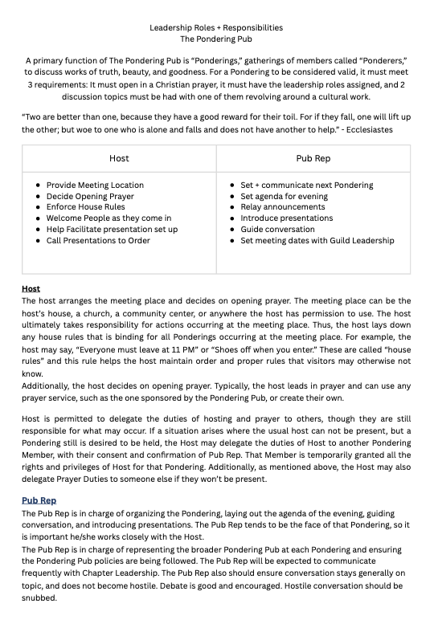
Attachment 1:
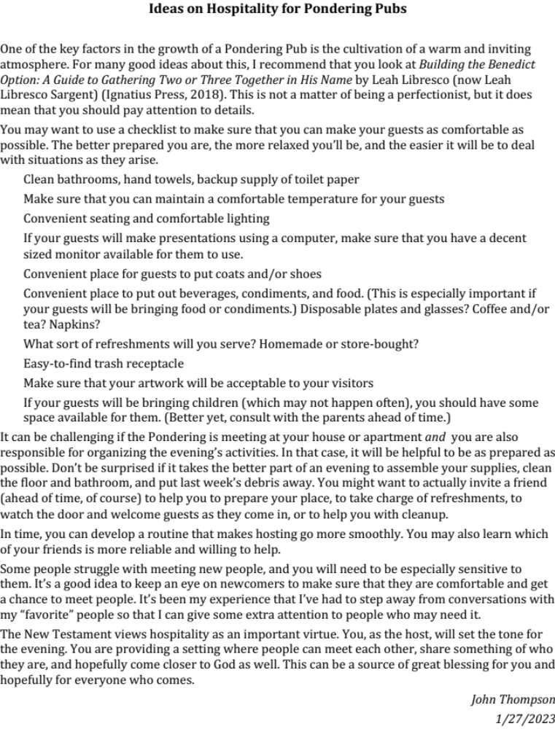
Attachment 2:

